Laser Therapeutic Devices of the Mustang 2000 Family

Yuri B. Glazkov, Alexander A. Radaev, Mikhail M. Ruchkin, Mikhail N. Titov

Introduction
It is known that the first investigations of laser influence on biological objects were performed by means of helium-neon (He-Ne) laser sources. These laser sources had been successfully used in various laser therapeutic devices for many years. Although many of them find use today, He-Ne laser sources are frequently replaced by semiconductor laser sources. The process of replacement was initiated in 1995 and it was actively stimulated both by developing 0.63-μm laser diodes and by postulating the identical irradiation efficiency of laser diodes to that of He-Ne laser sources [1]. Apart from that, semiconductor laser sources offered a number of advantages over gas laser sources in engineering principles, dimensions, design and serviceability. All these facts allowed semiconductor laser sources to be widely applied [2].
The conducted literature review has shown that laser therapy very frequently employs laser diodes of various spectral ranges and it seldom relies on other laser types, such as an ultraviolet nitrogen (N₂) laser (λ = 0.337 μm) applied in dermatology and in the treatment of burns [3], a blue helium−cadmium (He−Cd) laser (λ = 0.441 μm) applied in the treatment of various pathologies [4] and an infrared carbon dioxide (CO₂) laser (λ = 10.6 μm) [5, 6].
The equipment developed by the Scientific-and-Production Laser Center (SPLC) “Technika” Co. Ltd (Moscow, Russia) is an example of practical realization of modern construction principles of laser therapeutic devices being considered in this article. This company was selected because it has priority in the medical instrument-making industry and its catalogue comprises virtually all the examples of laser therapeutic equipment and supplied accessories.
Below we will consider basic principles which designers of the SPLC “Technika” Co. Ltd are guided by in their creating of laser therapeutic devices of the Mustang 2000 family.

Principles of Devices Configuration
There are a number of basic requirements to laser therapeutic devices for the purpose of high efficiency of procedures:
- High accuracy and stability of laser radiation parameters of a wide range;
- Control of laser radiation parameters: radiation power, radiation dose, and radiation wavelength;
- Possibility of laser radiation delivery to the exposure area;
- Simplicity of the use (visual controls, informativity of control systems, small dimensions and weight);
- High reliability and simplicity of technical service;
- Adequacy to modern safety requirements.
Compliance with all these requirements will provide high treatment efficiency.
The principle of modular configuration of laser therapeutic devices fully complies with the given requirements. In accordance with this principle, a device is figuratively divided into three compatible parts: a basic unit, radiation probes and attachments.
The basic unit is the base of a laser therapeutic device. Its functions are to set radiation modes and radiation parameters, indicate settings and control the operation of a device.
The variety of methods of therapeutic treatment demands the use of laser and light-emitting diodes with different radiation parameters. Various radiation probes can serve for these purposes. These radiation probes contain one or a number of lasers and light-emitting diodes, and an electronic device, which interfaces control signals from the basic unit to the laser.
Various optical attachments allow one to deliver radiation to the necessary area of exposure.
The modular principle allows one to use a wide range of laser and light-emitting diode probes, which have different characteristics of spectrum, time-space and energy, which in its turn, raises the treatment efficiency to a whole new level due to combined realization of different methods of laser therapy.
The Mustang 2000 laser therapeutic device is based on the modular principle and complies with all modern requirements. This is a device, which consists of a basic unit, removable radiation probes and attachments.

THE BASIC UNIT
sets, controls and indicates parameters:
radiation power, radiation dose, radiation wavelength, type of radiation probe

RADIATION PROBES:
general-purpose pulse radiation probes,
general-purpose continuous-wave radiation probes, and special probes

ATTACHMENTS:
mirror, magnetic, and optical attachments

The Mustang 2000 device based on the modular principle allows one to create on the basis of one basic unit both general-purpose, multi-type polyclinic kits, and specialized systems.

Basic Units
Depending on the type of configuration, the basic unit has 1, 2 or 4 channels for the connection of radiation probes with an option of independent setting of radiation frequency and radiation power for each channel. Devices are designed in the same style and differ from each other in the width of the frame, depending on the number of channels (Fig. 1 – 3). The choice of radiation channel is made by pushing the button on the device control panel.

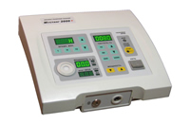
Fig. 1. The Mustang 2000 laser therapeutic device (one-channel basic unit)

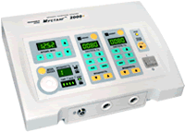
Fig. 2. The Mustang 2000 laser therapeutic device (two-channel basic unit)

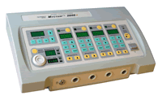
Fig. 3. The Mustang 2000 laser therapeutic device (four-channel basic unit)

When the device is switched on, it automatically identifies the types of radiation probes connected to the basic unit, and one by one it shows their titles and the number of the channel they are connected to, on the display.
The device has a built-in photometer, which allows one to measure radiation parameters for all types of the probes in the spectral range from ultraviolet with a wavelength of 365 nm to infrared with a wavelength of 1300 nm. The radiation power being measured, the device automatically identifies and displays the type of the connected probe, wavelength and radiation power in watt (for pulse radiation probes) or in milli-watt (for continuous-wave radiation probes).
During the procedure, the device measures and displays the radiation dose for each channel. This allows one to have a permanent control of the total radiation dose, without using any formulae or charts.
The radiation dose being calculated by means of formulae and charts, radiation pulse duration, as a rule, is taken to be 100 nsec (10⁻⁷ sec). Though this value is most typical for most pulse laser diodes used in laser therapeutic devices, however the range of pulse duration can be from 70 to 180 nsec, and the calculation of the dose by means of formulae and charts may lead to a significant mistake. The Mustang 2000 laser therapeutic device, when calculating the dose, measures and takes into account the radiation pulse duration of pulse laser diodes. The radiation dose is often given alone in methodological recommendations and literature without additional information on other parameters of radiation. In this case, the option of dose calculation is especially important.
Characteristic features of the Mustang 2000+ laser therapeutic device are as follows:
- One, two or four independent channels for the connection of radiation probes;
- An option of setting radiation frequency (modulation frequency) and radiation power separately for each channel;
- Wide choice of different laser and light-emitting diode removable radiation probes of pulse, continuous-wave and modulated modes in the range of wavelength from 365 to 1300 nm (from ultraviolet to infrared spectrum range);
- General-purpose unit, which displays the radiation parameters: the type of a radiation probe, radiation power, wavelength, radiation dose;
- An option to modulate radiation with the help of external sources: heart-rate and breath-rate sensors (BIO-controlled mode of modulation in accordance with the biorhythmicity of a patient), sources of special music programs, etc.;
- Versatility of the use and high efficiency of treatment, which is due to the option of practically any radiation mode and radiation parameters used in laser therapy;
- Conformity with standard requirements;
- High reliability;
- Modern design and well-thought-out ergonomics.
The Mustang 2000 device with its options does not have any analogies. Unique options of the device allow to create on its basis both general-purpose laser therapy rooms, which can realize practically all modern techniques of laser therapy, and specialized systems, which are aimed at the maximum effective treatment of a small group of diseases in one field of medicine.

Basic Specifications of the Mustang 2000 Laser Therapeutic Device
Number of channels | 1  2  4
Radiation mode | Pulse, continuous-wave, modulated
Radiation wavelength | From 365 nm to 1300 nm, depending on  the type of removable radiation probe
Pulse radiation power | Up to 350 W, depending on the type of  removable radiation probe
Continuous-wave radiation power | Up to 400 mW, depending on the type of removable radiation probe
Type of setting the pulse repetition frequency or modulation frequency | Fixed or random
Fixed pulse repetition frequencies of “quick choice”, Hz | 10, 80, 600, 3000
Range of frequency setting of “random choice”, Hz | 0.5 - 3000
Choice of exposure time | Fixed or random
Fixed values of exposure time of “quick choice” | 1, 10 minutes
Range of exposure time setting of “random choice” | 1 sec – 90 minutes
Range of controlled pulse radiation power, W | 2 - 99
Control of pulse power of radiation probes with a wavelength of 630 – 650 nm | Available
Range of controlled continuous-wave radiation power, mW | 1 – 400
Control of power of radiation probes with a wavelength of 1300 nm | Available
Control of power of light-emitting diode probes in a range of wavelength  from 365 to 880 nm | Available
Range of dose calculation | 0.01 mJ – 9999 J
Radiation wavelength digital display | Available
Digital display of removable radiation probe type | Available
Option of radiation modulation in BIO mode | Available
Electric power supply | 198…242 V / 50 Hz
Maximum power consumption, VA, no more than:  - one-channel basic unit  - two-channel basic unit  - four-channel basic unit | 14  14  28
Operating temperature range, ºС | +10…+35
Dimensions, mm:  - one-channel basic unit  - two-channel basic unit  - four-channel basic unit | 220 х 196 х 105  275 х 196 х 105  340 х 196 х 105
Weight, kg:  - one-channel basic unit  - two-channel basic unit  - four-channel basic unit | 1.6  1.6  2.8

General-Purpose Radiation Probes
General-purpose radiation probes have a single emitter and can be classified by type of laser or light-emitting diode (LED) radiation source, pulse or continuous-wave radiation mode, wavelength, and maximum radiation power (Fig. 4). They can be used both separately, and in combination with different attachments (mirror, magnetic, optical, and acupuncture). LED radiation probes can be used in combination with magnetic, mirror, and polarizing attachments.

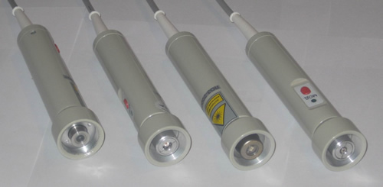
Fig. 4. Appearance of general-purpose radiation probes

General-Purpose Laser Radiation Probes of Pulse Radiation Mode
Type of Radiation Probe | Optical Range | Wavelength,  nm | Radiation Power, W,  not less than
LО1-2000 | Infrared | 890 | 5
LО2-2000 | Infrared | 890 | 10
LО3-2000 | Infrared | 890 | 15
LО4-2000 | Infrared | 890 | 20
LО7-2000 | Infrared | 890 | 80
LО7M-2000 | Infrared | 890 | 350
LОК2-2000 | Red | 630 - 650 | 5

General-Purpose Laser Radiation Probes of Continuous-Wave and Modulated
Radiation Modes
Type of Radiation Probe | Optical Range | Wavelength,  nm | Radiation Power, mW,  not less than
KLО1-2000 | Red | 658 | 5
КLО2-2000 | Red | 658 | 30
КLО3-2000 | Red | 635 | 10
КLО4-2000 | Red | 635 | 30
КLО5-2000 | Infrared | 830 | 40
КLО6-2000 | Infrared | 810 | 200
КLО6M-2000 | Infrared | 810 | 400
КLО7-2000 | Infrared | 1300 | 5
КLО8-2000 | Infrared | 780 | 100
КLО9-2000 | Green | 520 | 30
KLO-450-30 | Blue | 450 | 30
KLO-405-120 | Violet | 405 | 120

General-Purpose LED Radiation Probes of Continuous-Wave and Modulated
Radiation Modes
Type of Radiation Probe | Optical Range | Wavelength,  nm | Radiation Power, mW,  not less than
SО2-2000 | Infrared | 880 | 200
SО3-2000 | Red | 630 | 100
SО4-2000 | Yellow | 590 | 20
SО5-2000 | Green | 530 | 40
SО6-2000 | Blue | 470 | 70
SО7-2000 | Violet | 405 | 70

Matrix Radiation Probes
The МLO1К-2000 matrix laser radiation probe (Fig. 5) has ten infrared pulse laser diodes with a wavelength of 890 nm, maximum pulse radiation power of not less than 50 W and 12-cm² surface area for output radiation window.
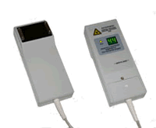
Fig. 5. Appearance of the MLO1K-2000 matrix radiation probe

The probe has a built-in power meter, a visual digital indicator, and automatic failure monitoring. It can be used in combination with special magnetic attachments of MM50 type.
The MLS-1 “Effect” matrix radiation probe (Fig. 6) is a combined laser-and-LED matrix. High efficiency of the use is due to the optimal choice of parameters of pulse laser (infrared and red) and LED (infrared, green and blue) radiation. There is an option of both simultaneous and separate work of a group of emitters.
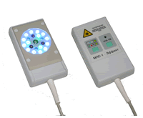
Fig. 6. Appearance of the MLS-1 “Effect” matrix radiation probe

The LO-2000 combined laser-and-LED radiation probe (Fig. 7) has one laser diode of pulse mode (890 nm / 7 W) and seven light-emitting diodes of continuous-wave and modulated modes (630 nm / 15 mW).
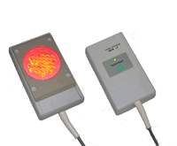
Fig. 7. Appearance of the LO-2000 combined laser-and-LED radiation probe

Each of the matrix LED radiation probes has 31 diodes and 15-cm² surface area for output radiation window.
The MS02-2000 probe of infrared range has seven light-emitting diodes and looks like general-purpose probes of continuous-wave radiation mode. The probes can operate in continuous-wave and modulated modes. The parameters are given in the below chart.

LED Radiation Probes of Continuous-Wave and Modulated Radiation Modes
Type of Radiation Probe | Optical Range | Wavelength,  nm | Radiation Power, mW,  not less than
МSО2-2000 | Infrared | 880 | 150
МSО3М-2000 | Red | 630 | 80
МSО4М-2000 | Yellow | 590 | 40
МSО5М-2000 | Green | 530 | 40
МSО6М-2000 | Blue | 470 | 70

Radiation Probes for Intravenous Irradiation of Blood
Radiation probes of the VLOK series are aimed at intravenous irradiation of blood with the help of the KIVL-02 disposable sterile light-guiding fibers. The probes are manufactured with both laser source, and the LED one. The probes have different wavelength and radiation power. The parameters of the VLOK radiation probes are given in two below charts. The probes are a bit bigger than a matchbox in size, and they can be easily fixed on the patient’s wrist with a strap in order to perform a procedure (Fig. 8).

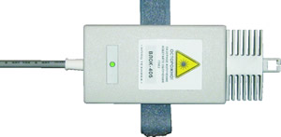
Fig. 8. Appearance of the VLOK radiation probe

Laser Radiation Probes for Intravenous Irradiation of Blood
Type of Radiation Probe | Optical Range | Wavelength,  nm | Radiation Power at the KIVL-02 Light-Guiding Fiber Output, mW,  not less than
VLOK | Red | 633 | 2
VLOK-М5 | Red | 633 | 5
VLOK-М10 | Red | 633 | 10
VLOK-М20 | Red | 633 | 20
VLOK-532 | Green | 532 | 1.5
VLOK-405 | Violet / Ultraviolet | 405 | 1.5
VLOK-808 | Infrared | 808 | 40

LED Radiation Probes for Intravenous Irradiation of Blood
Type of Radiation Probe | Optical Range | Wavelength,  nm | Radiation Power at the KIVL-02 Light-Guiding Fiber Output, mW,  not less than
VLOK-LED-530 | Green | 530 | 1.5
VLOK-LED-450 | Blue | 450 | 1.5
VLOK-LED-405 | Violet / Ultraviolet | 405 | 1.5
VLOK-LED-365 | Ultraviolet | 365 | 1.5

Optical Attachments
Optical attachments (Fig. 9, 10) are used in combination with general-purpose radiation probes and are aimed at delivering energy of laser radiation to the area of exposure. The parameters, which characterize an attachment, are indicatrix of diffusion and coefficient of radiation lead-in, which is the ratio of the power at the attachment output to the power at the attachment input. This coefficient depends not only on the type of attachment and its constructive features, but also on the type of laser source, and it can vary from 0.4 to 0.6.

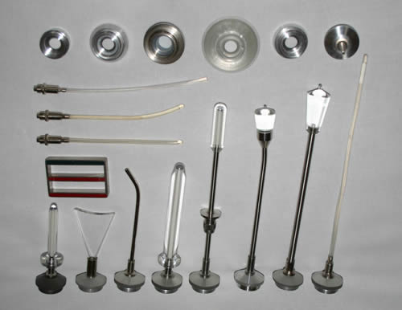
Fig. 9. Appearance of the optical attachments

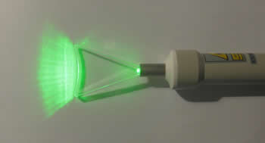

Fig. 10. Appearance of stomatological removable attachment at work

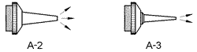 | A-2 and A-3 acupuncture attachments are used in reflexotherapy and aimed at the concentration of laser radiation on the acupuncture points. These attachments have the area of exposure point of 4 and 1 mm² respectively.
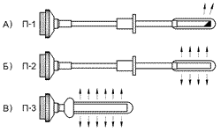 | P-1 (П-1) proctological attachment (Figure А) forms a radiation spot of 5 to 10 mm in size at an angle of 100 - 120º. It is used in urology for transrectal exposure on prostate.  P-2 (П-2) proctological attachment (Figure Б) disperses radiation equally on cylinder with a diameter of 12 mm and with a length of 30 mm. It is used in urology for irradiation of prostate (in a transrectal manner) or in proctology for irradiation of rectal walls. Dispersion on a large surface makes the power density significantly lower than in P-1 (П-1), which in some degree is compensated by its versatility.  P-3 (П-3) proctological attachment (Figure В) disperses radiation equally on cylinder with a diameter of 12 mm and with a length of 55 mm. It is used in proctology for irradiation of rectal walls (anal fissures, hemorrhoid, etc.).
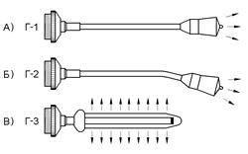 | G-1 (Г-1) and G-2 (Г-2) gynecological attachments (Figures А, Б) are used in gynecology for intravaginal irradiation of the cervix uteri and adnexa. These attachments form a radiation spot with a diameter of 18 - 20 mm in contact.  G-3 (Г-3) gynecological attachment (Figure В) disperses radiation equally on cylinder with a diameter of 14 mm and with a length of 80 mm. The attachment is aimed at intravaginal treatment of a number of inflammatory diseases.
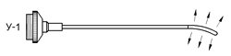 | U-1 (У-1) urological attachment is aimed at transurethral exposure on prostate and urethra. It is made of flexible material, and is 18 - 20 mm long. On its end, it has a dispersing cylindric part of high flexibility which is 20 mm long.
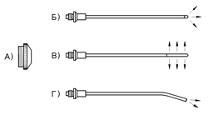 | L-1 otorhinolaryngological kit of attachments consists of 3 removable attachments and a special holder-connector, where a necessary attachment gets fixed.
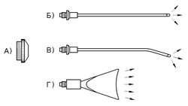 | S-1 kit of stomatological attachments consists of 3 removable attachments and a special holder-connector, where a necessary attachment gets fixed.
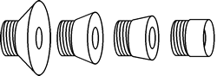 | ZN25 (diameter of 25 mm), ZN30 (diameter of 30 mm), ZN35 (diameter of 35 mm), ZN50 (diameter of 50 mm) mirror attachments are aimed at the mirror-contact type of exposure. They allow to decrease the losses of laser radiation energy, they protect the doctor and the patient from reflected radiation, provide hygiene of the procedure and allow to calculate the density of radiation dose easily enough. For the contact type of procedure with the help of mirror attachments, the effective exposure area is taken to be 1 cm², the dose density in this case is summary dose of exposure according to the values indicated on the display of the basic unit.

Magnetic Attachments
Magnetic attachments are aimed at combined target exposure of the magnetic field and laser radiation energy, which increases the efficiency of laser therapy. The ZM25, ZM35, ZM50, ZM150 attachments and the KM2 kit of magnetic attachments are used with general-purpose radiation probes for laser therapeutic devices of the Mustang 2000 family.
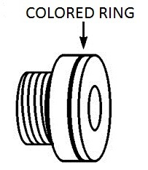 | ZM25, ZM35, ZM50 mirror magnetic attachments go in a plastic body and have a mirror working area. They combine positive features of magnetic and mirror attachments and have magnetic induction of 25, 35, 50 mT respectively in the working area. The COLORED RING shows with which pole this magnet is directed to the working area – with the north pole (a blue ring) or with the south pole (a red ring).  ZM150 attachments have magnetic induction of 150 mT and are constructed as a holder and a ring magnet. A ring magnet has two working areas with different poles of the magnetic field (north and south) and can be placed on the holder from either side.  KM2 kit of attachments has two holders and two ring magnets, which have different magnetic induction from different sides: 25 and 50 mT, 50 and 75 mT respectively.
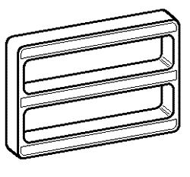 | MM50 magnetic attachment is aimed at being used with ML01K matrix radiation probes. Magnetic attachment has a magnetic field induction of 50 mT. MM50 attachment additionally has a mirror working area.

BIO-Control Unit for the Mustang 2000 Laser Therapeutic Device
The BIO-control unit (Fig. 11) is aimed at synchronization of time parameters of laser exposure with the biorhythmicity of a particular patient. Heart rate and breath signals get fixed with the help of special sensors. The unit is connected to the Mustang 2000 laser device and allows to perform laser exposure modulated in accordance with the signals of heart rate and breath rate of the patient, and also with the floating frequency of 7 - 14 Hz.
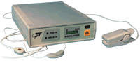

Fig. 11. The BIO-control unit

In the BIO-control mode, laser radiation power is modulated by three signals. Carrier frequency is modulated by floating frequency of 7 – 14 Hz (it is set by a special generator). In this case, radiation power of carrier frequency in the absence of heart rate and breath signals makes 1/3 from the maximum value. When the heart-rate and breath-rate signals are available, radiation is additionally modulated, and 1/3 is added to the amplitude in the systole and inspiration phases. As a result, radiation power is minimal at expiration in the diastole phase, and at inspiration in the systole phase (most favorable moments of exposure) it reaches the maximum value.
The advantages of BIO-controlled chrono-laser therapy compared to conventional methods are the following: systematic treatment due to immunocorrection and intensification of antioxidant defense; recovery from desynchronosis; normalization of blood flow; regional and central blood-flow synchronization. This eliminates the causes and consequences of the disease.

References
1. Tuner J., Hode L. Laser therapy in dentistry and medicine. Stockholm, Sweden: Prima Books, 1996, p. 236.
2. Kozlov V. I., Morskov V. F. Promising developments of laser medical devices. Vladimirskii Meditsinskii Vestnik, 1995, Vol. 2, pp. 263−268.
3. Gerasimova L. I., Zhizhin V. N., Kizhaev E. V. et al. Thermal and radiant burns. System for the informational support of diagnostics and treatment. Ed. by G. I. Nazarenko. Moscow: Meditsina, 1996, p. 248.
4. Kryuk A. S., Mostovnikov V. A., Khokhlov I. V., Serdyuchenko N. S. Therapeutic efficiency of low-intensity laser radiation. Minsk, Byelorussia: Nauka i Technika, 1986, p. 231.
5. Galetty G. Farther elements in favour of low energy−density (LED) CO₂ laser capacity to penetrate tissues. The Laser Barcelona International Congress, 1994, p. 9.
6. Ussia G. Beneficial effects of CO₂. LLLT in the Postoperative Period after Aesthetic Surgery. The Laser Barcelona International Congress, 1994, p. 37.

