TECHNICA-PRO

OFFERS
LASER SHOWER, LASER BIDET, and LASER BATH

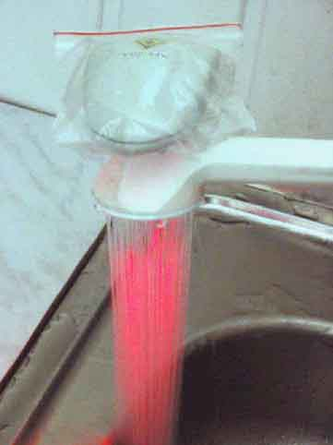

These systems are used to treat a wide range of various diseases. They produce a general sanitary effect, similar to that observed during a physiotherapeutic session. These systems eliminate fatigue and nervous breakdown. In order to produce a therapeutic effect, a portable Creolka laser emits a laser beam that irradiates a sheet of water. Depending on the disease type, one of 30 types of the Creolka laser, manufactured by our firm, can be used. These lasers differ in their output power, wavelength, and irradiation mode (pulsed or continuous-wave). A laser bidet produces a specific therapeutic effect in the case of gynecology and proctology. Because of the simplicity and availability of such a session, it can be employed as a prophylactic means.

Today and forever
Warranty period is 40 months
The device comes with a
700 MB “Laser-Medicine Encyclopedia” CD-ROM

Phone: +007 095 254 1592, 251 2450

Fax: +007 095 251 2450
http://www.gamma.ru/technica
E-mail: gta@technica.msk.ru,
a_radaev@mtu-net.ru

70, Bol’shaya Gruzinskaya St., Office 19, Moscow, Russia

