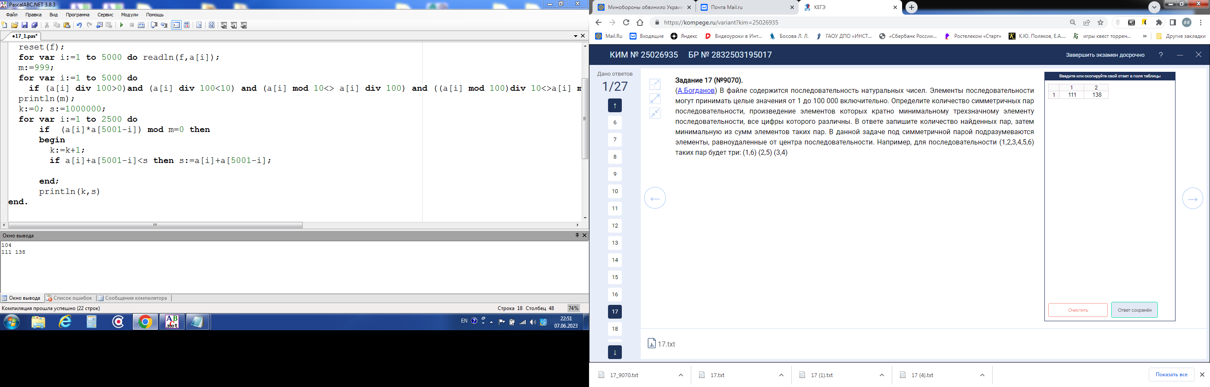

**var** k,s,m:integer;

f:text;

a: **array**[1..5000] **of** integer;

**begin**

assign(f,'C:\17_9070.txt');

reset(f);

**for var** i:=1 **to** 5000 **do** readln(f,a[i]);

m:=999;

**for var** i:=1 **to** 5000 **do**

**if** (a[i] **div** 100>0)**and** (a[i] **div** 100<10) **and** (a[i] **mod** 10<> a[i] **div** 100) **and** ((a[i] **mod** 100)**div** 10<>a[i] **mod** 10) **and**((a[i] **mod** 100 **div** 10)<>a[i] **div** 100) **and** (a[i] <m) **then** m:=a[i];

k:=0; s:=1000000;

**for var** i:=1 **to** 2500 **do**

**if** (a[i]*a[5001-i]) **mod** m=0 **then**

**begin**

k:=k+1;

**if** a[i]+a[5001-i]<s **then** s:=a[i]+a[5001-i];

**end**;

println(k,s)

**end**.

____________________________________________________________________________ 111 138

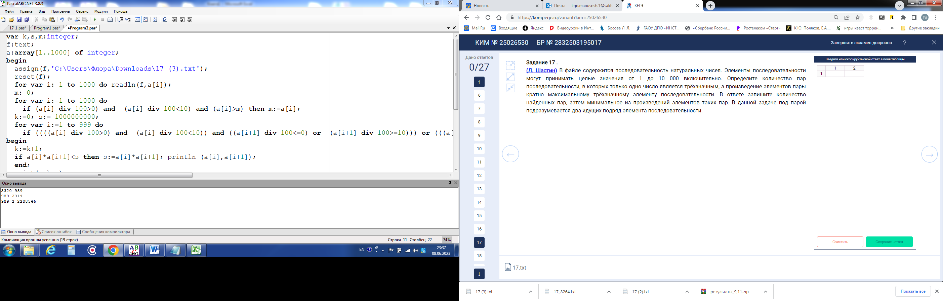

**var** k,s,m:integer;

f:text;

a:**array**[1..1000] **of** integer;

**begin**

assign(f,'C:\17.txt');

reset(f);

**for var** i:=1 **to** 1000 **do** readln(f,a[i]);

m:=0;

**for var** i:=1 **to** 1000 **do**

**if** (a[i] **div** 100>0) **and** (a[i] **div** 100<10) **and** (a[i]>m) **then** m:=a[i];

k:=0; s:= 1000000000;

**for var** i:=1 **to** 999 **do**

**if** ((((a[i] **div** 100>0) **and** (a[i] **div** 100<10)) **and** ((a[i+1] **div** 100<=0) **or** (a[i+1] **div** 100>=10))) **or** (((a[i] **div** 100<=0) **or** (a[i] **div** 100>=10)) **and** ((a[i+1] **div** 100>0) **and** (a[i+1] **div** 100<10)))) **and** ((a[i]*a[i+1]) **mod** m=0) **then**

**begin**

k:=k+1;

**if** a[i]*a[i+1]<s **then** s:=a[i]*a[i+1]; println (a[i],a[i+1]);

**end**;

print(m,k,s);

**end**.

__________________________________________________________________________ 2 2288546